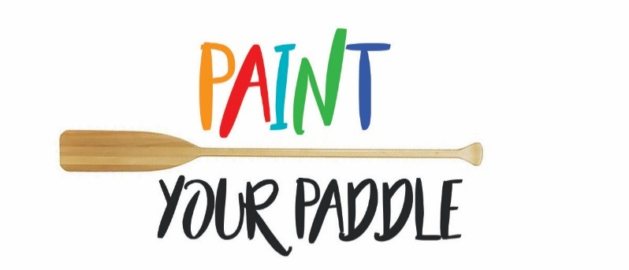
We are launching a canoe paddle art contest to celebrate the spectacular waterways in Leeds and the Thousand Islands and to leave a legacy in our community as part of Canada's 150th birthday.
150 canoe paddles are available for artists and creative people to design in a way that celebrates our local heritage, our natural environment or our communities using any method or medium they choose (paint, burning, photography, textile, carving, etc.).
The finished paddles will be used to create a future community art installation as a legacy of Canada 150 celebrations.
The 150 painted paddles will be displayed at Canada Day Celebrations in Seeley's Bay on Saturday July 1st and at other community events throughout the year.
Contest winners will be chosen by the public in an online vote on the Township's Facebook page @Twp.Leeds1000Islands. The three paddles with the most likes will be announced on Thursday December 7th at the Lansdowne Tree Lighting and the winning artists will be awarded prizes (to be announced) to commemorate their work.
_________________________________________________________
Anyone who lives, works, or plays in Leeds and the Thousand Islands is eligible to participate in the contest.
To enter, complete a contest registration form.
Paddles will be available for pickup at the Township of Leeds and Thousand Islands Municipal Office at 1233 Prince St. Lansdowne beginning Monday May 1st at 9:00 a.m. Completed paddles must be returned to the same location by Friday June 23 2017 at 4:30 p.m.
The paddles remain the property of the Township of Leeds and the Thousand Islands.
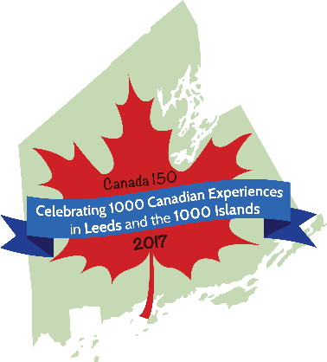
For additional information please contact Emma emma@townshipleeds.on.ca
