BUSINESS AMBASSADOR TOOLKIT
Dear Business Ambassadors, in this toolkit you will find a few examples how you can help us promote Richmond Hill as The Smart Place for Business.
Please feel free to utilize some, or all, of the examples below. Hopefully, this will help you find other additional venues how you can promote Richmond Hill.
Examples of Social Media Posts to Promote Richmond Hill
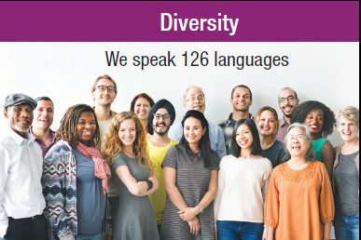
#RichmondHill has a diverse workforce that speaks 126 languages. #diversity #SmartPlaceForBusiness #workforce #talent #BusinessAmbassador. Learn more about Richmond Hill @rh_ecdev at http://www.BusinessRichmondHill.ca
#Talent is everywhere in #RichmondHill - 77% of residents have a post-secondary degree, diploma, or certificate. One of Canada’s most educated workforces. #SmartPlaceForBusiness #BusinessAmbassador - Learn more about Richmond Hill @rh_ecdev at http://www.BusinessRichmondHill.ca
#RichmondHill is located in the heart of Canada's technology hub, and home to #global #leaders in #innovation. #SmartPlaceForBusiness #BusinessAmbassador - Learn more about Richmond Hill @rh_ecdev at http://www.BusinessRichmondHill.ca

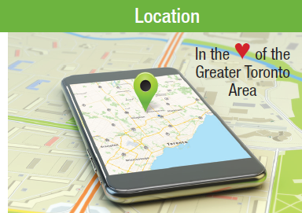
#RichmondHill is located in the heart of the Greater Toronto Area, and provides easy access to highways, trains, public transit and a future connection to the Toronto subway system. #BusinessAmbassador - Learn more about Richmond Hill @rh_ecdev at http://www.BusinessRichmondHill.ca

#RichmondHill supports all business sectors with focus on four high-growth, high value sectors which are Professional, Scientific & Technical Services, Healthcare, Finance & Insurance, and Information & Cultural Industries. #BusinessAmbassador - Learn more about Richmond Hill @rh_ecdev at http://www.BusinessRichmondHill.ca

Work alongside #award winning #businesses in #RichmondHill who have achieved local, national and international #industry #rankings. #SmartPlaceForBusiness #BusinessAmbassador - Learn more about Richmond Hill @rh_ecdev at http://www.BusinessRichmondHill.ca

Richmond Hill Profile (For Promotion on Website and Email)

Option #1: Short Version
Richmond Hill, known as The Smart Place for Business, has become a destination where business leaders and exceptional talent come to find success. Richmond Hill is the perfect location for businesses with easy access to all transportation hubs, a highly-educated workforce, a dynamic Economic Development support team and a diverse and welcoming community. Please visit www.BusinessRichmondHill.ca for more information.

Option #2: Long Version
Richmond Hill, known as The Smart Place for Business, has become a destination where business leaders and exceptional talent come to find success. Richmond Hill is the perfect location for businesses with easy access to all transportation hubs, a highly-educated workforce, a dynamic Economic Development support team and a diverse and welcoming community.
Richmond Hill, located just north of Toronto, is one of the fastest growing and most diverse communities in Canada.
With a thriving economy comprised of world class head offices and knowledge-based companies in information technology, health industries, finance and insurance, and a vibrant creative sector, Richmond Hill is where successful businesses locate.
Richmond Hill has one of Canada's most educated workforces, with over three-quarters of residents with post-secondary education. You will have access to a superbly-trained workforce to support your growing business. Richmond Hill also has competitive development charges and comparatively low property tax rates in the Greater Toronto Area, allowing businesses to properly manage costs and focus on growth.
Please visit www.BusinessRichmondHill.ca and contact the Richmond Hill Economic Development team today to start the conversation.

Networking Events
Networking at various events is an active strategy to promote Richmond Hill as a Business Ambassador. For a list of free networking events, conferences, seminars, trade shows and more, you can visit http://www.eventbrite.ca and narrow down the events by categories and locations.
The first Business Ambassador Networking event is scheduled for October 2018, date to be announced. If you are interested in hosting the event at your location, please contact us at ecdev@richmondhill.ca or call 905-747-6382. We will provide foods and drinks.

Email Signature
You can include an email signature to showcase your involvement in the Business Ambassador Program:
“A proud Richmond Hill Business Ambassador. Learn more about Richmond Hill here.”
Promotional Materials
If you require additional printed promotional materials that were given to you at the orientation session and included in your Business Ambassador folder, please contact us at ecdev@richmondhill.ca or call 905-747-6382.

Thank you for all your support!
Richmond Hill Economic Development Team

