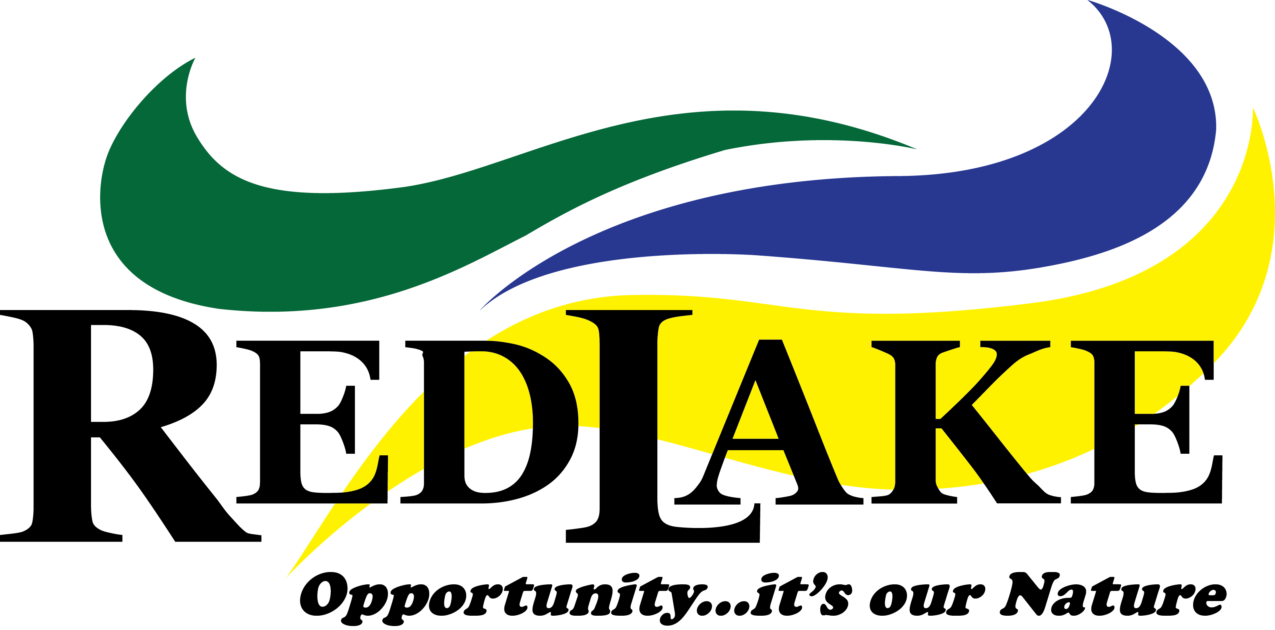

Position Title: | Economic Development Officer
Reports To: | CAO
# of Direct Reports: | 0
Status: | Full-time
Revision Date: | October 15, 2024

JOB PURPOSE

Reporting to the Chief Administration Officer, the Economic Development Officer will be responsible for the coordination of the Municipality of Red Lake’s economic development activities with the intent of attracting new businesses, encouraging investment opportunities, increasing job opportunities and identifying opportunities for sustainable community growth by promoting and marketing the Municipality of Red Lake as great place to live, visit and do business.

SPECIFIC ACCOUNTABILITIES
- Develop knowledge of key industry growth sections in the region, identify prospective investment, expansion leads and follow up with outreach calls, visits, meetings.
- Prepare economic impact reports that identify, develop, and implement economic development strategies, programs and projects that are designed to attract businesses and new residents to the community, while promoting the Municipality of Red Lake.
- Create and deliver presentations with relevant stakeholders, community leaders, business organizations, potential investors, and other regional committees.
- Demonstrate continuous improvement efforts to enhance operations, streamline work processes and work cooperatively to deliver the highest customer service excellence.
- Work directly with local businesses to facilitate access to municipal processes and referrals to other economic development support agencies.
- Coordinate economic development and tourism activities between internal departments, external agencies, and neighboring communities.
- Identify and apply for grant opportunities, prepare grant proposals to secure funding for economic development initiatives. Develop and maintain professional relationships with potential funders, key stakeholders of government, foundations, and private investors.
- Conduct research on economic trends, market conditions and industry opportunities to identify potential areas for economic growth. Analyze data to assess the economic health of the region and the municipality.

WORKPLACE REQUIREMENTS
- Valid Ontario Driver’s License in good standing
- Ability to sit and do computer work for sustained periods of time
- Location: Onsite Red Lake, Ontario
RELATIONSHIPS
Internal: All departments within the Municipality of Red Lake and Council.
External: General public.
KNOWLEDGE, SKILLS & TECHNICAL ABILITIES
- University degree in Community Economic Development, Urban Innovation, Business Administration, or a related field.
- Certified Economic Developer (Ec.D.) Designation would be an asset.
- Ability to deal with confidential and sensitive information.
- Proven ability to multi-task and prioritize projects to meet deadlines in a fast-paced environment.
- 3 years of economic development and relationship management experience
- Experience in planning marketing campaigns and knowledge in developing, researching, writing marketing materials.
- Strong analytical skills with the ability to interpret economic data and trends.
- Proficiency in Microsoft Office and SharePoint.
- Knowledge of the Northern Ontario resource sector would be an asset.
- Experience with municipal budget planning, forecasting and maintenance.
- Familiarity with grant writing, fundraising and project management.
- Excellent verbal and written communication skills with ability to problem solve.

Demonstrate ability and commitment to the Core & Leadership Competencies:
- TBD

