January 26, 2024

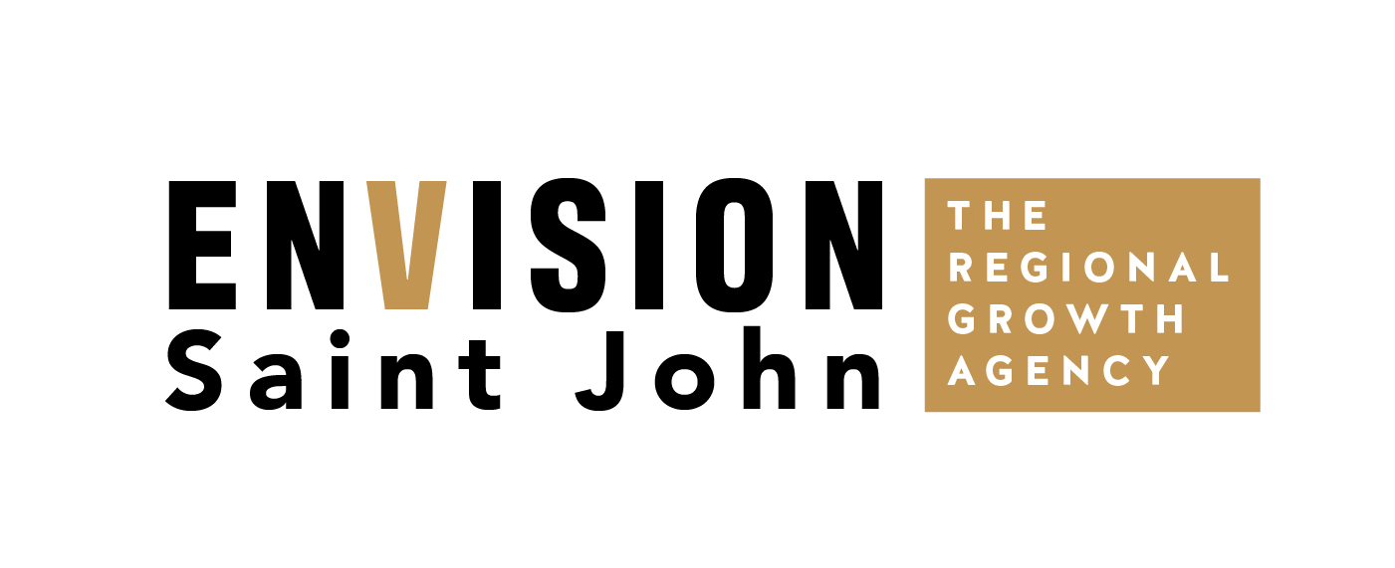

Impact Loan marketing Plan

Envision SAint John: The Regional Growth Agency

### Impact Loan marketing Plan

### Plan Overview

Envision Saint John manages the Impact Loan program for Saint John and there is a need to provide awareness to entrepreneurs about programming and funding that is offered.

We will share success stories of past impact loan receipts and profile services provided within our agency and through agency partners.   
  
We will lean into businesses startups/expansions within the trades as there is a need to provide stronger awareness to this demographic.

Messaging will expand beyond Impact Loan funding, but also highlight how Envision Saint John supports entrepreneurs via one-on-one mentorships, navigation of the ecosystem and partner training and development opportunities.

### Target

* Entrepreneurs (20-55)
* Trade Sector Businesses

**KEY MESSAGES**

* In 2023, Envision Saint John supported more than **130 entrepreneurs** in the Saint John Region. We help foster small and medium-sized businesses to reach their full potential.
* Our whole-system view helps easily navigate the entrepreneurial ecosystem and create connections to successfully build your business.

### Tactics/Budget

**Video  
Budget: $2,500**

* ConnexionWorks has hired local videographer Tyler Burr to capture footage in programs/courses. I am proposing to connect with Tyler for fee on shooting a couple interviews from Impact Loan Growth Stories to pull together a 60 -90 second highlight reel that showcases the evolution of training/development to business launches.
  + The video will live on Envision website and be shared on social media. Craig/Nada can share via outreach with entrepreneurs.

**Radio  
Budget: $2,500**

* Narrow in on stations that would play on trades job sites (Q889, Country 94)

**Social Media Ads   
Budget: $500**

* Run Social Media Ads that feature past recipients. Use Place Branding and pull quotes from stories – link to new Entrepreneurship & Business Growth page on Envision Website.
* Focus on Meta (Facebook and Instagram for advertising)

**Media Outreach  
Budget: N/A**

* Pitch feature of entrepreneurial supports and highlight recent Impact Loan businesses within the community that are willing to share/promote their story.

**National Volunteer Week Feature   
Budget: N/A**

* National Volunteer Week is April 21-27, opportunity to feature the Impact Loan committee on our social channels.

**TOTAL COST: $5,500**

### REPORTING

|  |  |
| --- | --- |
| **Tactic** | **Metric** |
| Social Media | Reach, Views, Engagement |
| Radio | Listenership Stats from Stations |
| Media | # of articles picked up |