Innovation Park
Marketing Plan
2023

SUMMARY
The goal of the marketing plan is to generate interest in the Innovation Park; interest that will lead to the sale of 17 lots located across the 23 acre business park. This project supports the Corporate Strategic Plan Priority #1: Facilitate Appropriate Growth in our Communities. 2023 will see the construction and servicing of the park completed and the kick off of more aggressive marketing tactics in order to sell the lots.
PRODUCT OVERVIEW
When multiple innovators work in close proximity ideas percolate, achievement is celebrated and shared, new thinking crosses boundaries, and innovation multiplies. That is the inspiration behind the Innovation Park, bordered by trails, history and nature, and the future home to some of the region’s most innovative companies.
The Innovation Park is 23 acres on 17 lots of municipally owned, zoned Business Park lands. They will be partially serviced with water, hydro, and internet. Each tenant will require a septic system.
TARGET MARKET
The Innovation Park was created to foster and build on our innovative spirit in clean energy. Businesses who operate in the clean energy space along with those in research, technology, and healthcare are the primary target market for the park along with the additional permitted uses in the zoning by-law listed below.
Permitted uses:
- Accessory retail store
- Accessory food and beverage uses
- Conference Centre
- Facilities for Education, Training and Skills Development
- Research and Development uses
- Data-processing centres
- Offices
- Businesses and activities associated with green technology or renewable energy
- Businesses and activities supportive of the nuclear service industry
- Business incubator uses
- Public utilities
- Industry, non-effluent producing
MARKETING ACTION PLAN
The marketing plan that follows is based on the Content Marketing Funnel model seen below. Which is a standard practice in creating marketing plans.
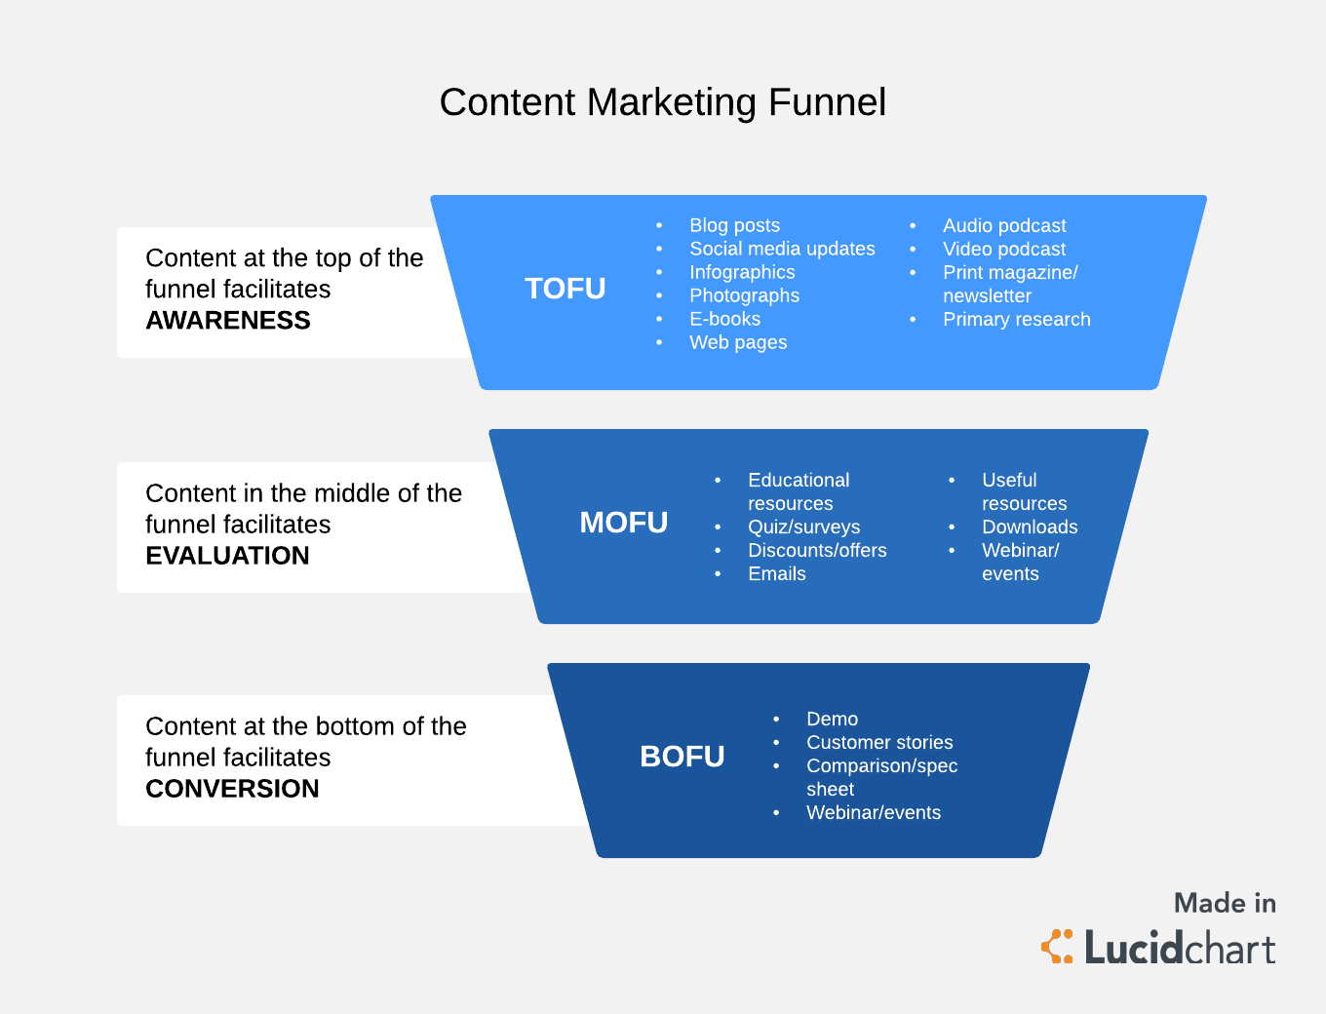

AWARENESS
(Blogs, Social media content, infographics, photography, ebook, webpages, podcasts, videos, print/newsletter, research)
Task | Description | Completion Date | Budget
Innovation Park webpage | SaugeenShores.ca/InnovationPark | July 2022 | $0
Print Materials Developed | - Stand-up banner  - Invest Saugeen Shores Booklet  - Innovation Park 2 page overview  - Clean Energy Map  - Innovation Park Post Card | February –April 2023 | $1,000
Branded Promotional Products | Mints  Water bottles | February 2023 | $1,000
Video Developed | Short video to showcase the Innovation Park | March 2023 | $5,000
Podcast Episode | Record an episode on the vision and strategy behind the development of the Park. | April 2023 | $0
Economic Development Update – e news | Highlight the opportunity for businesses in the monthly newsletter | April 2023 | $0
Report to Council | Bring a report to council regarding the marketing efforts to date and the initiatives planned for the remainder of 2023 | April 2023 | $0
Chamber and BIA newsletters | Share the information regarding the park and the types of businesses the town is targeting with local partners. | Q2-Q3 | $0

EVALUATION
(Educational resources, surveys, offers, emails, useful resources, downloads, webinar/events)
Task | Description | Completion Date | Budget
Canadian Nuclear Association Conference | Meet with those in the clean energy industry to garner interest. | February  2023/2024 | $2,000
MIPIM Conference | Real estate conference in Cannes, France organized by the County of Bruce to attract investment to the area. | March 2023 | County Budget
Site Selection Magazine – March Issue – Ontario Feature | Feature in Site Selector Magazine with a circulation of 40,000. | March 2023 | $5,000 USD
Groundbreaking Ceremony & Press Release | Photo opportunity ahead of the start of the construction on the Park. | April 2023 | $0
Visitor’s Centre Show Room | Set up a Show Room for the Park at the Port Elgin Visitor’s Centre including the marketing materials developed to date. | May 2023 | $0
Mail out to potential tenants | Clean energy network. | Q3-Q4 | $1,000
Publications – information on the park | Set up publication features for the Park. | Q3-Q4 | $1,000
Calls/emails to prospective tenants | Number of calls/emails per quarter | Quarterly | $0
Radio Spots | Work with Communications to secure additional opportunities to talk about the park on public forums. | TBD | $0
Press Release | Highlight any milestones in the construction/ development of the Park. | As required | $0

CONVERSION
(Demos, customer stories, comparison/spec sheet, webinar/events)
Task | Description | Completion Date | Budget
Host information session webinar | Invite prospective tenants to participate and have the opportunity to ask questions.  Could include current tenants if already secured. | Q1 2024 | $0
Innovation Park site visits | Take potential investors to visit the site. | As required | $0
Publications – Tenant Stories | Highlight those who have signed on to locate in the Park. | As tenants secured | $1,000
Report to Council | Bring reports to Council as new tenants sign on for approval of purchase agreements. | As required | $0
Press Release | Welcome new owners/tenants to the Park | As required | $0

