EDAC Submission: Advertising Campaign
- Purpose of Project (including anticipated outcomes)
- Effectiveness / Meeting Objectives (if known)
- Challenges & Changes made
- Target Audience (demographics)
- Any specifics as detailed in the particular Awards Categories – N/A
- Any details regarding the sustainability of your project. Sustainability is about being mindful of one’s place, processes, and mentality in order to influence change for the better of our communities, local and global.

Title: Revitalizing Hamilton Commercial District CIP Campaign
Cover Image:
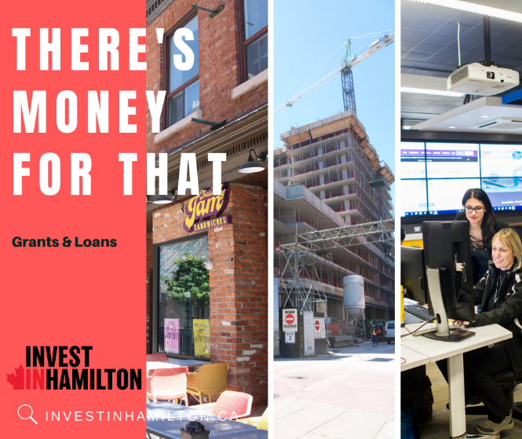
The Revitalizing Hamilton Commercial District Community Improvement Plan (RHCD CIP) advertising campaign was created with the purpose of promoting new opportunities and incentives available through the revised RHCD CIP that was approved by Council in September 2021.
Community Improvement Plans are planning tools that can be difficult to understand and hard to find. Our objective with the campaign was to break down information into an easy-to-understand and visual campaign that would be able to target the right audiences on incentive programs and opportunities. Our social media campaign consisted of catchy verbiage with “billboard-like-text” and imagery that aimed to resonate with the audience.
The key elements of the campaign were to:
- Market incentives offered for incorporating environmental and housing affordability measures into developments,
- Market incentives offered for establishing start-up or office space in Hamilton and,
- Market incentives for a new commercial vacancy assistance program.
The broad target audience of this campaign were decision-makers in and around the Greater Toronto and Hamilton Area. Decision makers are identified in our Economic Development Marketing Strategy as a persona that includes C-Suite, Founders, VP’s, Directors, and Managers. The specific target audience varied depending on the element of the RHCD CIP being marketed. For example, ads about environmental sustainability and housing affordability were targeted towards developers. Ads about start-up and office incentives were targeted towards tech start-ups/scale-ups and entrepreneurs in regional innovation centres. Finally, ads about the Community Vacancy Assistance Program targeted existing and new business owners.
The social media campaign spanned across the months of June and July 2022. Through targeted LinkedIn ads, the campaign was able to effectively identify the target audience within a specific geography. As the team’s first advertising campaign using paid LinkedIn ads, one of the challenges that the team experienced during the execution of the campaign was understanding LinkedIn’s algorithm for paid advertising. It was identified that week-long campaigns did not work well for paid advertising, therefore the length of the campaign was changed to run over the span of one month. As a result of the change, LinkedIn posts generated over 22,000 impressions and 70 clicks in total, and resulted in direct phone calls to the team’s Urban Renewal Incentives Coordinator.

