18 – AF – 14

TOWN OF FORT FRANCES

TERMS OF REFERENCE FOR
CONDUCTING A LAND USE AND ECONOMIC DEVELOPMENT FEASIBILTIY STUDY FOR THE RE-DEVELOPMENT OF THE SHEVLIN WOOD YARD AT 900 BLOCK SCOTT STREET AND THE FORMER NURSING STATION/GATEWAY TO THE MARKET SQUARE AT 420 MOWAT AVENUE

R.F.P. NO. 18-AF-14

November 21, 2018

TABLE OF CONTENTS

SECTION 1 | REQUEST FOR PROPOSAL | 3
SECTION 2 | GENERAL INFORMATION AND INSTRUCTIONS | 4 - 8
SECTION 3 | PROJECT DESCRIPTION | 9 - 11
SECTION 4 | PROPOSAL REQUIREMENTS | 12 - 14

APPENDIX “A” EXISTING SHEVLIN WOODYARD SITE PICTURES AND MAP APPENDIX “B” EXISTING GATEWAY TO MARKET SQUARE SITE PICTURES AND MAP
APPENDIX “C” STATUTORY DECLARATION
APPENDIX “D” FORT FRANCES BOUNDLESS BRANDING INFORMATION

TOWN OF FORT FRANCES REQUEST FOR PROPOSAL

FOR

CONDUCTING A LAND USE AND ECONOMIC DEVELOPMENT FEASIBILTIY STUDY FOR THE RE-DEVELOPMENT OF THE SHEVLIN WOOD YARD AT 900 BLOCK SCOTT STREET AND THE FORMER NURSING STATION/GATEWAY TO THE MARKET SQUARE AT 420 MOWAT AVENUE

R.F.P. NO. 18 – AF – 14

The Town of Fort Frances wishes to obtain proposals from a reputable consulting firm to complete a study on the re-development of the Shevlin Wood Yard and former Resolute Forest Products’ nursing station (hereon referred to as Gateway to Market Square). The project is to be conducted through consultation with local stakeholders, the economic development office and Mayor and Council. The purpose of this study is to evaluate how the properties can be best used to maximize its economic potential. The study will analyze the site and the surrounding environment to understand which investments are appropriate and the steps that are needed to attract that investment.

This study will involve all appropriate and relevant stakeholders, such as the Ministry of Northern Development and Mines, FedNor, the Rainy River Future Development Corporation (RRFDC), and the Town of Fort Frances to develop an acceptable plan. Sealed 5 proposals, and clearly marked shall be submitted to:

Doug Brown, CAO
Town of Fort Frances
320 Portage Avenue
Fort Frances, Ontario P9A 3P9

A CONSULTING FIRM FOR THE PURPOSE OF CONDUCTING A LAND USE AND ECONOMIC DEVELOPMENT FEASIBILTIY STUDY FOR THE RE-DEVELOPMENT OF THE SHEVLIN WOOD YARD AT 900 BLOCK SCOTT STREET AND THE FORMER NURSING STATION/GATEWAY TO THE MARKET SQUARE AT 420 MOWAT AVENUE

RFP 18 – AF – 14

and must be received no later than:

Tuesday, December 18, 2018 AT 2:00 P.M. (CST)

Proposals will be opened publicly immediately thereafter in the Committee Room of the Civic Centre. They will then be evaluated by the Town and the successful company will be notified in January or the early part of February of 2019.

Information and documents relating to this Request for Proposal, are available at the Information Desk, Fort Frances Civic Centre, 320 Portage Avenue, Fort Frances, Ontario P9A 3P9. 807-274- 5323.

Questions regarding this proposal must be directed to Doug Brown, Chief Administrator Officer, at telephone (807) 274-5323 facsimile (807) 274-8479 email dbrown@fortfrances.ca.

The lowest or any proposal will not necessarily be accepted. The Town reserves the right to reject any or all proposals, to waive irregularities and informalities therein, and to award the Contract in the best interest of the Town in its sole and unfettered discretion. The accepted proposal must be approved by Council.

SECTION 2

GENERAL INFORMATION AND INSTRUCTIONS INDEX

  - Intent of the Request for Proposals

  - Qualifications

  - Proposal Closing Date

  - Informal Proposals

  - Errors and Omission

  - List of Addenda

  - Tender Withdrawal and Award

  - Tax Management (HST)

  - Ontario Retail Sales Tax

  - Fax Transmittal

  - Municipal Freedom of Information and Protection of Privacy Act

  - Pages Numbered

  - Location of Fort Frances

  - Consultant’s Insurance

  - Inquiries

SECTION 2

GENERAL INFORMATION AND INSTRUCTIONS

  - INTENT OF THE REQUEST FOR PROPOSALS

The purpose of the request for proposals is to retain a reputable consulting firm to undertake a redevelopment study of the Shevlin Wood Yard, located at 900 Block Scott Street, and the Gateway to Market Square, located on 420 Mowat Avenue. This study will involve the following:

    - Review the background reports and conceptual designs previously completed for the property redevelopment

    - Conduct public consultations, no less than two, on the proposed use of the property.

    - Evaluate the recommendations from the public consultations and previous studies and develop a feasible plan, to be presented in-person to the Economic Development Office and Mayor and Council.

    - Complete any revisions and present in-person their final findings to the Economic Development Office and Mayor and Council

    - The successful firm will be required to travel to the Town of Fort Frances to conduct the public consultations as well as to present their findings to Mayor and Council and required sub committees.

  - QUALIFICATIONS

The lowest or any proposal will not necessarily be accepted. The Town reserves the right to reject any or all proposals, to waive irregularities and informalities therein, and to award the contract in the best interest of the Town in its sole and unfettered discretion. An accepted proposal must be approved by Council.

  - CLOSING DATE

The Request for Proposals closes at 2:00p.m. Local Time (C.S.T.), Tuesday, December 18, 2018 and will be publicly opened immediately thereafter at the Committee Room, Civic Centre, Fort Frances, Ontario.

Five (5) copies of the proposal, fully completed, sealed and marked "R.F.P. No. 18-AF-14" must be delivered by mail or otherwise, to the Administrator, not later than 2:00 p.m. (C.S.T) on the closing date.

  - INFORMAL PROPOSALS

All proposals provided and all entries shall be in ink or typewritten. Proposals which are incomplete, conditional or obscure or which contain additions not called for, erasures, alterations or irregularities of any kind, or in which any of the prices are obviously unbalanced, may be rejected as informal.

The Town reserves the right to disqualify proposals not submitted in strict accordance with the terms

and conditions of the Terms of Reference.

  - ERRORS AND OMISSION

The successful firm shall examine the Terms of Reference Documents as soon as possible. Any errors, omissions or conflicts discovered shall be reported to the Chief Administrative Officer immediately.

Verbal instruction and/or communications will not be accepted.

  - LIST OF ADDENDA

During the request for proposals period, consulting firms may be advised by Addenda of required additions to, deletions from, or alterations in the Terms of Reference Documents. All such changes shall become an integral part of the Terms of Reference Documents and shall be allowed for in arriving at the Total Proposal Price. All Addenda received during the request for proposals period shall be acknowledged.

  - PROPOSAL WITHDRAWAL AND AWARD

Proposals received by the Administrator prior to Closing may be withdrawn upon written application only. The last proposal received shall invalidate all previous proposals received from the same consulting firm. Withdrawal of proposals shall be by letter bearing an official company or corporation signature and seal only.

No contracts will be awarded until after the proposal has been approved by Council. Council reserves the right to:
- reject any recommendation;
- reject any or all proposals;
- accept any proposal deemed to be in the best interest of the Town, or
- disqualify proposals not submitted in strict accordance with requirements of the terms of reference documents.

Exception may be made to any contract, which is funded by a Ministry of the Province of Ontario on behalf of the Corporation. However, any final decision for awarding of a Contract is subject to the concurrence of the Council.

Consulting firms are informed that it is a condition of the Terms of Reference Documents that each proposal shall remain in force from the closing date of the request of proposal until forty-five (45) calendar days thereafter unless the consulting firm has been formally rejected.

  - TAX MANAGEMENT (HST)

As it is the responsibility of the consulting firm to determine levy and collection of the Harmonized Sales Tax (HST), amounts bid shall show separately the HST amount, or alternatively cite the basis of exemption in lieu thereof.

  - ONTARIO RETAIL SALES TAX

Where contracts are awarded to non-resident Ontario consulting firms, they are required to either:
- Provide a copy of a valid Retail Sales Tax Vendor Permit, or
- file with the Town a copy of the letter of compliance issued by the Ontario Retail Sales Tax Branch.

Failure to comply will result in 4% of each payment due to the Contract to be withheld for remittance to the Treasurer of Ontario.

  - FAX TRANSMITTAL

Proposals may be submitted by Fax transmittal (807-274-8479) subject to additional conditions:

- All terms and conditions outlined in the Terms of Reference apply, including duplicate fax transmittals

- All original proposal documents and enclosures are received within forty-eight (48) hours of the closing date of the request for proposals, and

- The Town assumes no responsibility whatsoever for proper receipt of such Fax transmittals.

  - MUNICIPAL FREEDOM OF INFORMATION PROTECTION OF PRIVACY ACT

The Town is governed by the Municipal Freedom of Information and Protection of Privacy Act, therefore consulting firms must accept that proposal contents can be made public as a condition of the request for proposal process.

  - PAGES NUMBERED

All pages of the proposal document submitted must be numbered.

  - LOCATION OF FORT FRANCES

The Town of Fort Frances is located in the District of Rainy River, approximately 350 kilometers west of Thunder Bay, Ontario and 425 kilometers East of Winnipeg, Manitoba. The Town is bounded to the north and the east by Couchiching First Nation and the unorganized Township of Miscampbell, to the west by the Township of Alberton, and to the south by the United States of America. Also, please note that Fort Frances is in the Central Time Zone.

  - CONSULTING FIRM’S INSURANCE

The successful consulting firm shall take out and keep in force throughout the duration of the Contract, a comprehensive policy of Professional Liability in the amount of not less than $2,000,000.00 inclusive per occurrence.

The Town of Fort Frances shall be named as an additional insured thereunder, a certified copy of the policy or certificate thereof shall be deposited upon signing of the Agreement or as the Town may direct.

  - INQUIRIES
Questions regarding the Terms of Reference must be directed to: Doug Brown, CAO
Chief Administrative Officer,

Town of Fort Frances

320 Portage Avenue Fort Frances, Ontario P9A 3P9

Telephone: 807-274-5323 ext 1213
Fax: 807-274-8479
Email: dbrown@fortfrances.ca

SECTION 3 PROJECT DESCRIPTION
INDEX

  - GENERAL INFORMATION ON THE DESIGN ACTIVITIES

  - SCOPE OF WORK

  - OTHER SPECIFICATIONS FOR THE DESIGN ACTIVITIES

SECTION 3 PROJECT DESCRIPTION
  - GENERAL INFORMATION ON THE STUDY

    - The Town of Fort Frances wishes to hire, by Request for Proposal (RFP), a consulting firm with an expertise in land use and economic development planning to provide advice on the possible uses for these two properties and adjacent properties. This study will include community wide public consultations and at least three draft design plans, with a class “C” estimate (where appropriate). The consultants will review various options for the properties and determine community priorities for development that will result in the best economic outcome. Three draft design plans will be submitted and presented to Council for review. The consulting firm is then expected to complete any revisions and present the final report to Mayor and Council.

.
  - SCOPE OF WORK

The purpose of the request for proposals is to retain a reputable firm to complete a study on the redevelopment of the Shevlin Wood Yard, on 900 Block Scott Street, and Gateway to Market Square on 420 Mowat Avenue. These activities involves the following five main components:

    - Review the background reports and conceptual designs previously completed for the property redevelopment.

    - Conduct public consultations on the proposed use of the property.

      - Consultations are to be conducted with the Economic Development Office, Mayor and Council, key stakeholders, and community at large.
      - Consultations are to take place during times that will facilitate the majority of stakeholders.

    - Evaluate the recommendations & feedback from the public consultations and previous studies and develop three draft design plans, to be presented in-person to Mayor and Council.

    - Complete any revisions and present in-person a final report to Mayor and Council

    - The successful firm will be required to travel to the Town of Fort Frances to conduct the public consultations as well as to present the draft and final report to Mayor and Council.

  - OTHER SPECIFICATIONS FOR THE STUDY

      - The Shevlin Wood Yard was the former site of the mill's wood storage area. The Shevlin Wood Yard is a 22.688-acre lot. It is located on the community’s waterfront adjacent to the Sorting Gap Marina, facing North on Scott Street in the East end of Fort Frances. See appendix A for the overview map outlining key infrastructure in close proximity to the Shevlin Woodyard site

      - The Gateway to Market Square is located in the heart of Fort Frances, meters away from the US/Canadian Border. The site faces West on Mowat Avenue, behind the CIBC building on the South side. The site is still occupied by an existing structure that once served as a former nursing station. See appendix B for the overview map outlining key infrastructure in close proximity to the Nursing station site

      - The intent of the Town of Fort Frances is that the study’s proposals and recommendations take into consideration the new Fort Frances Boundless brand/vision.
      - The consultant shall consider other adjacent private property acquisitions that may benefit the preferred final design.
      - The final design layout shall include all municipal surface infrastructure such as roadways, sidewalks & bike path cc…

SECTION 4 PROPOSAL REQUIREMENTS
INDEX

  - PROPOSAL REQUIREMENTS SUBMITTED BY CONSULTING FIRM

  - PROPOSAL EVALUATION

  - OCCUPATIONAL HEALTH & SAFETY PLAN

  - CONTRACT

SECTION 4 PROPOSAL REQUIREMENTS
  - PROPOSAL REQUIREMENTS SUBMITTED BY CONSULTING FIRM

The proposals prepared by the firms will clearly indicate that the study will be carried in accordance with the Terms of Reference 18-AF-14.

Each firm’s proposal must contain at least, but is not necessarily limited to the following:

    - A work chart or work schedule showing the timing of the major tasks and milestones

    - The consulting firm shall describe their previous work of this type, highlighting their experience and expertise with the specific requirements of this project. If the firm intends to partner with others to complete certain components, the experience and expertise of those partner companies must also be described, citing previous relevant work.

    - The consulting firm shall identify the Project Manager and other staff, and list the responsibilities of each. Qualifications of the firm’s Project Manager and key personnel should be outlined. Any substitution of staff during the course of the Design works will not be permitted without approval of the Chief Administrative Officer.

    - Maximum total cost of the project broken down by deliverable, where major tasks or milestones, field inspection work, report writing, printing costs and other disbursements are listed separately.

    - Per diem rates for key personnel involved in the project and an estimate of the number of hours that project staff will spend on each specific task.

    - A listing of any special circumstances required to complete the study.

    - Identify any possible gaps in the Terms of Reference and how these gaps will be taken into account in the design activities.

    - Submit a listing of previous projects of similar scale or type completed for Municipal or institutional clients.

    - Five (5) hardcopies of the proposal & plus one electronic revision will be submitted

    - All Documents will be in MS (Word & Excel) Office Format.

  - PROPOSAL EVALUATION

The Town of Fort Frances will review the proposal submitted by each individual firm during January 2019. A scoring system will be utilized on the following categories:

    - Quality of the proposal submitted - ease of understanding, required components of the Design Activities, and work schedule.

    - Past Experience in completing similar design activities.

    - Key Personnel assigned to the project

    - Proposal Cost

    - Schedule

It should be clearly understood that the Town of Fort Frances has the right to assign weighting to each of the 5 above mentioned categories and if any proposal submitted fails to include any mandatory requirements as outlined in the Terms of Reference, the proposal is automatically disqualified.

  - OCCUPATIONAL HEALTH & SAFETY PLAN

The proposed Occupational Health and Safety Plan shall outline the firm’s general approach to Occupational Health and Safety.

The consulting firm will be responsible for meeting all of the “employer” obligations under the Occupational Health and Safety Act (OHSA) and shall ensure that all work is carried out in accordance with the OHSA and all applicable regulations. This includes but is not limited to, the duties to: provide a safe workplace; provide information and educate the workers on workplace hazards; appoint a competent supervisor; prepare and provide a health and safety policy; implement a comprehensive health and safety program to support the policy; and take every reasonable precaution to protect the health and safety of workers.

The firm shall submit a statutory declaration with the proposal: Appendix “C”.

  - CONTRACT

The consulting firm shall include a draft contract of engagement with their proposal.

The consulting firm shall enter into a design contract with the Corporation of the Town of Fort Frances. The contract shall indicate that work to be undertaken shall be done to the satisfaction of the Municipality according to the request for proposal and for the amount agreed upon by the two parties. The contract shall also indicate that no additional money shall be paid to the consulting firm for any additional work for which prior authorization has not been given in writing. The contract shall contain, as a minimum, the Request for Proposal and the Proposal accepted.

APPENDIX “A”

EXISTING SHEVLIN WOODYARD SITE PICTURES AND MAP

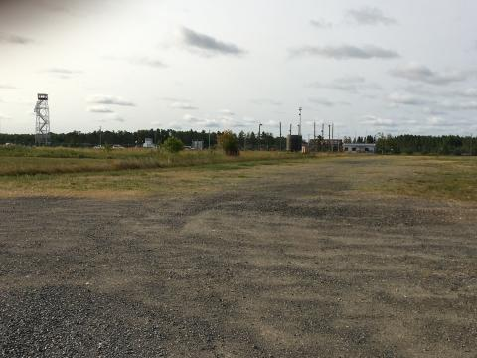
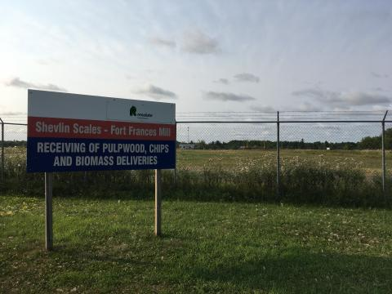

APPENDIX “B”

EXISTING GATEWAY TO MARKET SQUARE SITE PICTURES AND MAP

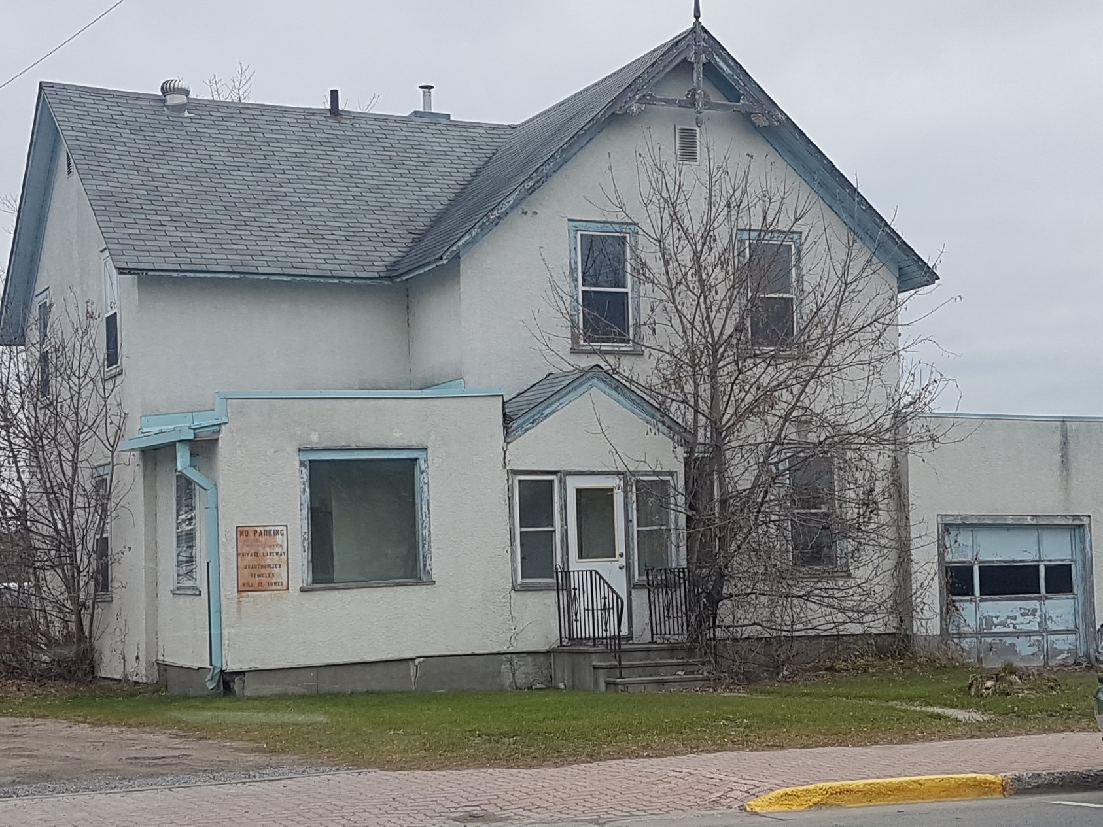

January, 2014 – FINAL

APPENDIX “C”

STATUTORY DECLARATION

STATUTORY DECLARATION

In submitting this proposal, I/We, on behalf of
Legal Name of Company
certify the following:

- I/We have a health and safety policy and will maintain a program to implement such policy as required by clause 25(2) (j) the Occupational Health and Safety Act, R.S.O. 1990, c.O.1, as amended, (the “OHSA”).

- With respect to the services being offered in this proposal, I/We and our proposed sub- contractors, acknowledge the responsibility to, and shall:

  - fulfill all of the “employer” obligations under the OHSA and ensure that all work is carried out in accordance with the OHSA and its regulations.

  - ensure that adequate and competent supervision is provided as per the OHSA to protect the health and safety of workers; and

  - provide information and instruction to all employees to ensure they are informed of the hazards inherent in the work and understand the procedures for minimizing the risk of injury or illness.

- I/We agree to take every precaution reasonable in the circumstances for the protection of worker health and safety, as required under the OHSA.

Dated at this day of 2018.

(Authorized signing agent for the Consulting firm)

(Title)

(Telephone Number)

APPENDIX “D”
FORT FRANCES BOUNDLESS BRANDING BACKGROUND INFORMATION

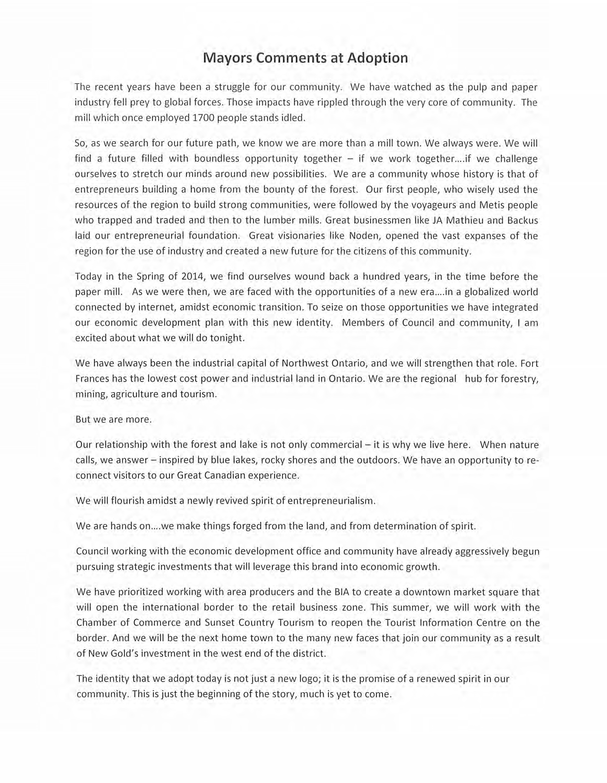

For more information on the Town’s Boundless Branding, please see link attached.

https://www.fortfrances.ca/town/mayor-council/boundless-brand

