Department of the Chief Administrative Officer
Economic Development and Tourism Division

EDAC 2018 Marketing Canada Awards – Promotional Item
The Perth County Tartan is a unique promotional item created to popularize and strengthen the identity of charming rural Perth County in an imaginative way. The official launch of the Perth County Tartan took place on National Tartan Day on April 6th, 2017, bringing forth our rich cultural heritage and an opportunity to embrace our promising future.

The Perth County tartan serves as a visual image of important features of Perth County. The colours, in combination, are taken from the Perth County Crest (1800’s) and the Perth County Logo (2009) to reflect the past and the present. The Perth County Tartan meaningfully represents the County - its past, present, and future. The shades of green represent the strong agricultural presence in Perth County. Blue represents the many rivers and creeks that flow through the fertile farmland. Red is for the blood sacrificed by the early settlers and veterans who gave their lives so that we could prosper. Gold signifies the industrious nature of the people of Perth County. (See Appendix A)

When the tartan was officially chosen at council back in April 2017, it drew an immediate response from the public. When it was first featured in The Beacon Herald, Stratford’s major newspaper, the phone at the local Scottish shop began ringing right away. The tartan is one-of-a-kind, having passed through the Scottish Tartans Authority to ensure it isn't too close to any other officially registered tartan. It then received approval from the Scottish Register of Tartans.

The tartan was produced and is sold in a purposeful manner – it has to have eye appeal to get people to embrace it, and the story behind it needs to be prevalent so when individuals wear the Perth County Tartan, they can tell that story. Several different products have been produced with the Perth County tartan such as bow ties, scarves, hats, etc. so that every person can find a product that suits them (See Appendix B). Chair of the Perth County Tartan Committee, Helen Dowd, explained that it is important to have people understand the symbolism of the tartan, and so each product comes with a card explaining the meaning behind the colours.

In 2017, National Tartan Day and Canada’s Sesquicentennial Anniversary provided us with an opportunity to reflect on the important contributions our Scottish immigrants and their descendants have made to our rural communities. The Perth County Tartan was created to commemorate the 150th anniversary celebrations of Canada. This anniversary was a great opportunity to celebrate what it means to be Canadian and as part of this celebration, the Perth County Tartan is an effective way to showcase and symbolize Perth County’s identity. The development of the tartan presented an opportunity to celebrate the history of Perth County, and those that have settled in the region, as well as the link between the past and the future. The Tartan furthers the creativity and dignity of the Perth County brand identity.

APPENDIX A

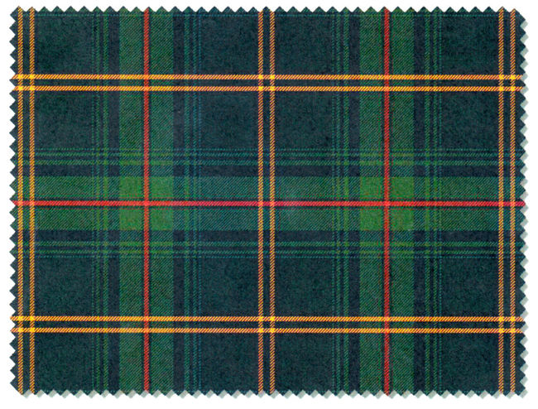

APPENDIX B

