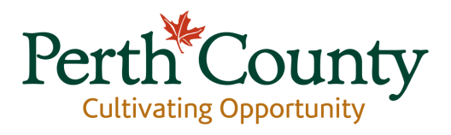
Department of the Chief Administrative Officer
Economic Development and Tourism Division

EDAC 2018 Marketing Canada Awards – Events
Perth County 2018 Tourism Familiarization Tour

The 2018 Tourism Familiarization Tour was a unique event that promoted tourism opportunities and attractions in Perth County in a fun and interactive way. The Economic Development and Tourism Division at Perth County hosted two busloads of key frontline staff in the Tourism industry throughout Stratford, St. Marys and Perth County on a one day tour across Perth County where we visited five incredible tourism destinations. In only nine hours, two busses toured a Certified Organic Farm Soiled Reputation, dined at one-of-a-kind Bake Shop and Tea Room Harry Ten Shilling, had a locally catered lunch and sampled Shakespeare Brewing craft beer at the amazing Stratford-Perth Museum, toured an Artisan Cheese facility and learned from the Swiss Master Cheesemaker at Stonetown Cheese, and learned how syrup is made at Hoover’s Maple Syrup. It was an excellent day filled with great people (all involved in the Tourism and Economic Development industry), where we visited numerous unique businesses, ate delicious food, and had lots of fun! (See Appendix A)

When considering how to best encourage tourism and educate those working in the industry about experiences within Perth County, it became clear that there was no better way than simply getting out and playing the role of a tourist. The Tourism Familiarization Tour was a free opportunity for this key audience, and we quickly learned how high the demands was for an experience like this as every spot on the first bus filled in under 24 hours, and we were completely sold out soon after. Spending a day as a visitor of Perth County allowed each attendee of the Tourism Familiarization Tour see this area in a whole new light, and discover more than they ever knew existed within the borders of Perth County. Individuals who went on this tour varied from Municipal Mayors, County Councilors, Tourism Officers, Accommodators, Travel Writers, Stratford Festival Staff, and more. To ensure inclusivity of the entire county, our stops included unique destinations from all four of Perth County’s member municipalities.
To start the day off right, each guest was greeted at our meeting spot with local muffins from Hick’s Café and had the opportunity to network prior to loading onto the busses. Guests of the Tourism Familiarization Tour were also all given a Perth County bag to hold their purchases from the varying stops, a 2018 ‘Discover More’ brochure to explore destinations that were not on the tour, a Perth County/Stratford map to assist with further Perth County discovery, and a Social Media Cheat Sheet. The Social Media Cheat Sheet (See Appendix B) that each guest was given included the day’s official hashtag #PerthCoFam18, as well as website and social media information for every stop of the tour. This allowed attendees to easily follow, like, share, and tag the different businesses that were visited on the tour as well as include the businesses page information in any live posts from the day.
Business owners and employees who were featured on this tour were thrilled with how the day turned out. Every business that was included in the tour was incredibly thankful for the opportunity to be promoted to this target audience and to have the chance to further popularize their respective experiences.
Overall, the 2018 Tourism Familiarization Tour was a major success. When asked in a follow up guest experience survey “How helpful was the content presented at the 2018 Perth County Tourism Familiarization Tour?” 87% of attendees responded with Very Helpful/Extremely Helpful. Those who were able to attend the tour were shocked and impressed at all the hidden gems that exist in Perth County, and took the knowledge of these exceptional experiences from each municipality with them to further encourage Perth County tourism.

APPENDIX A (4 Pages)

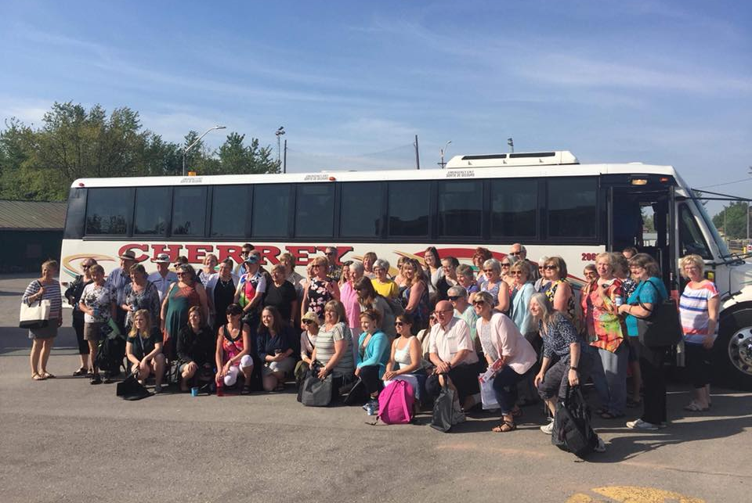

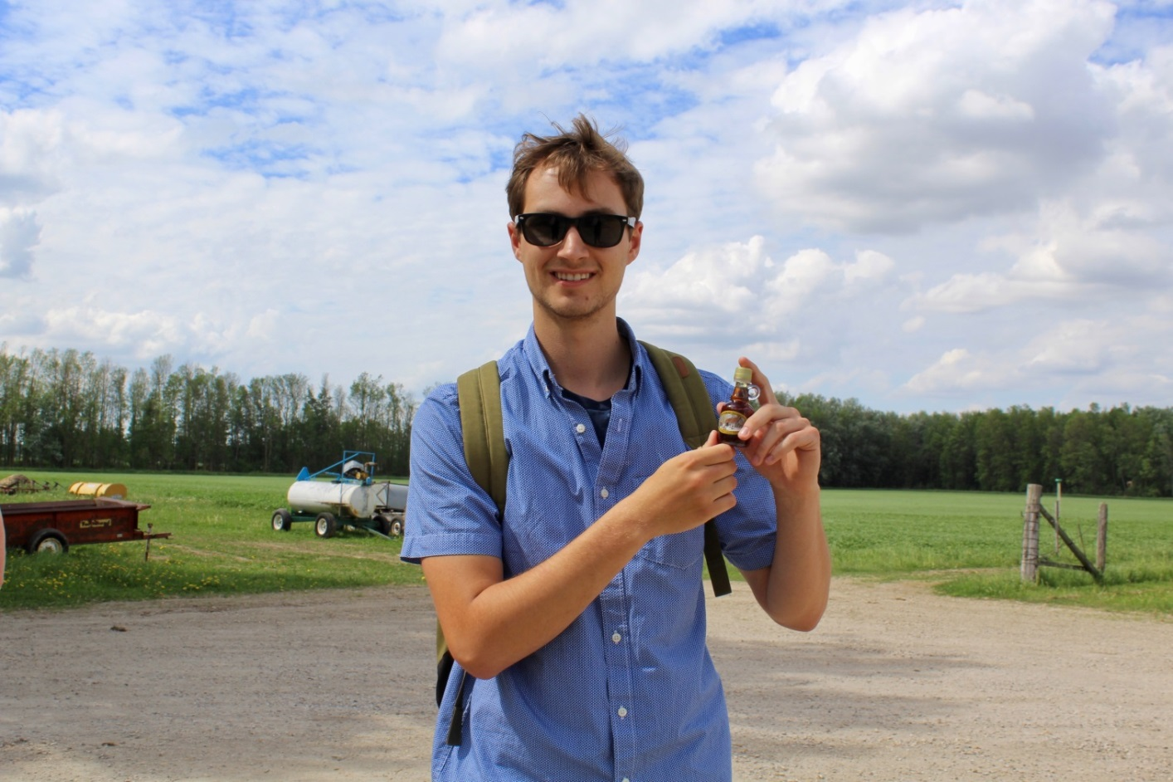
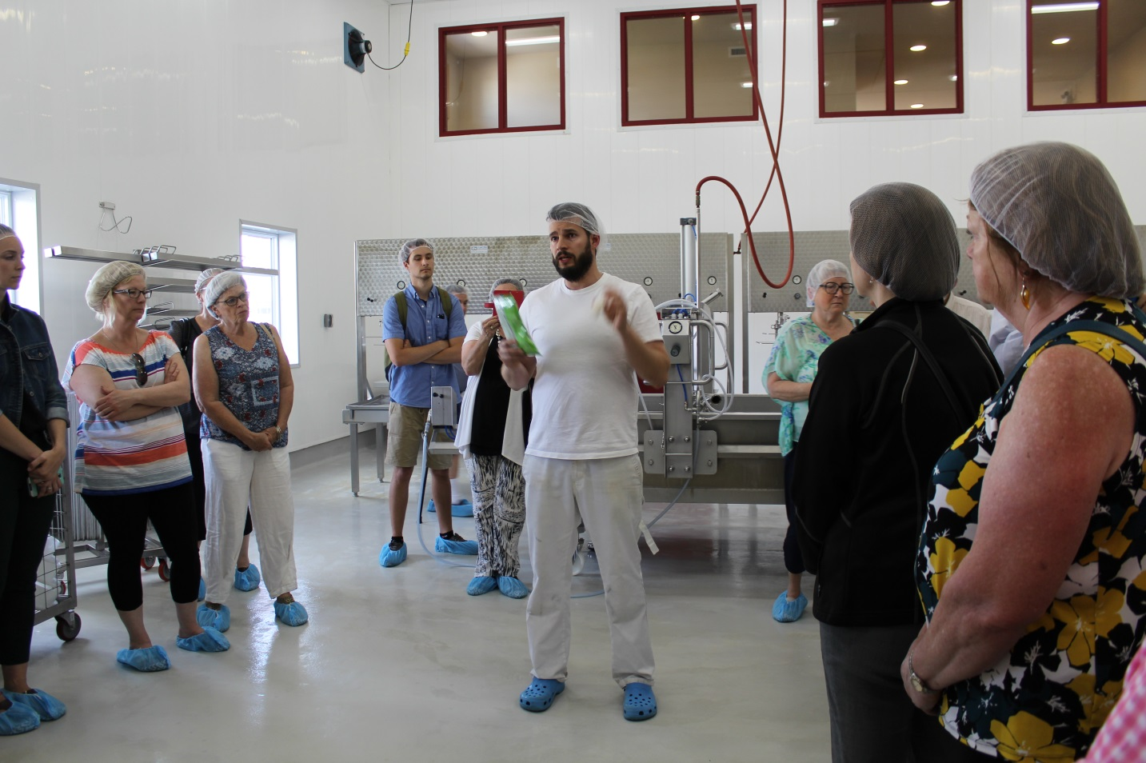

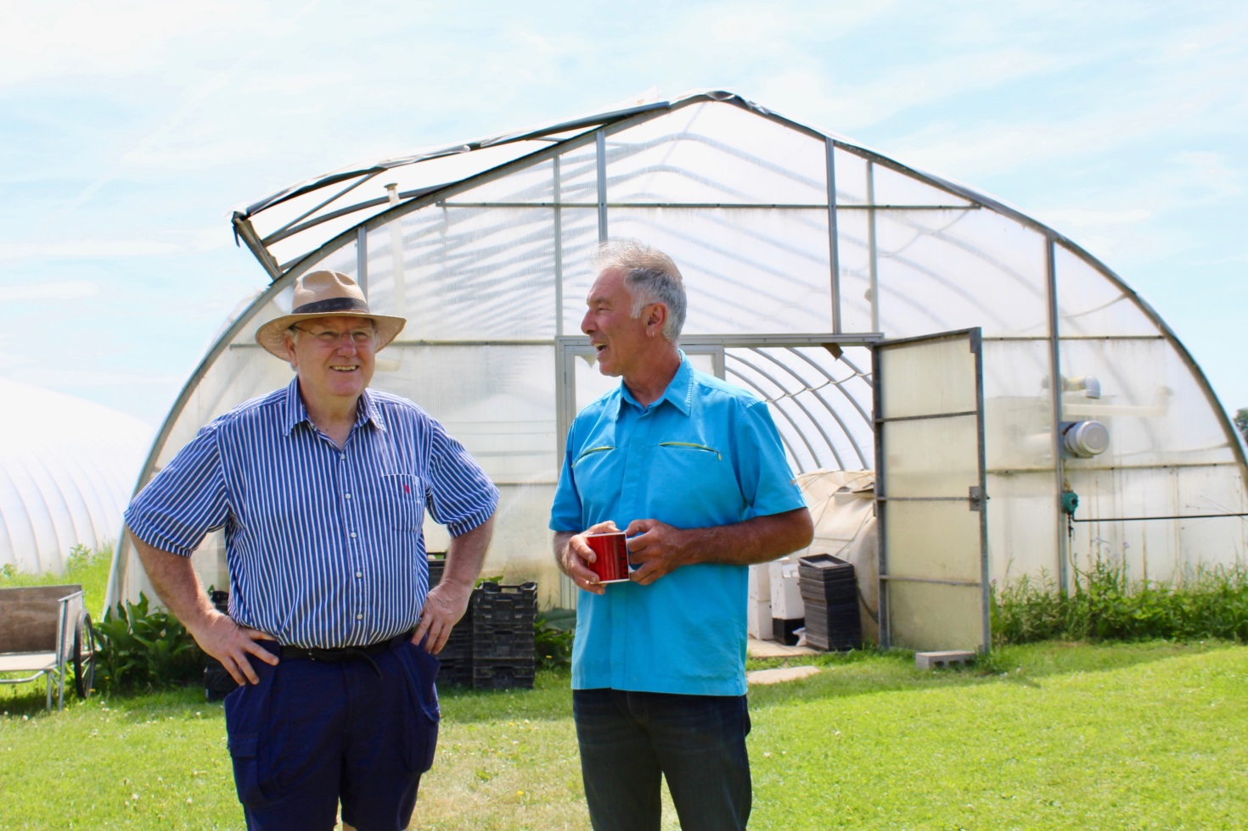
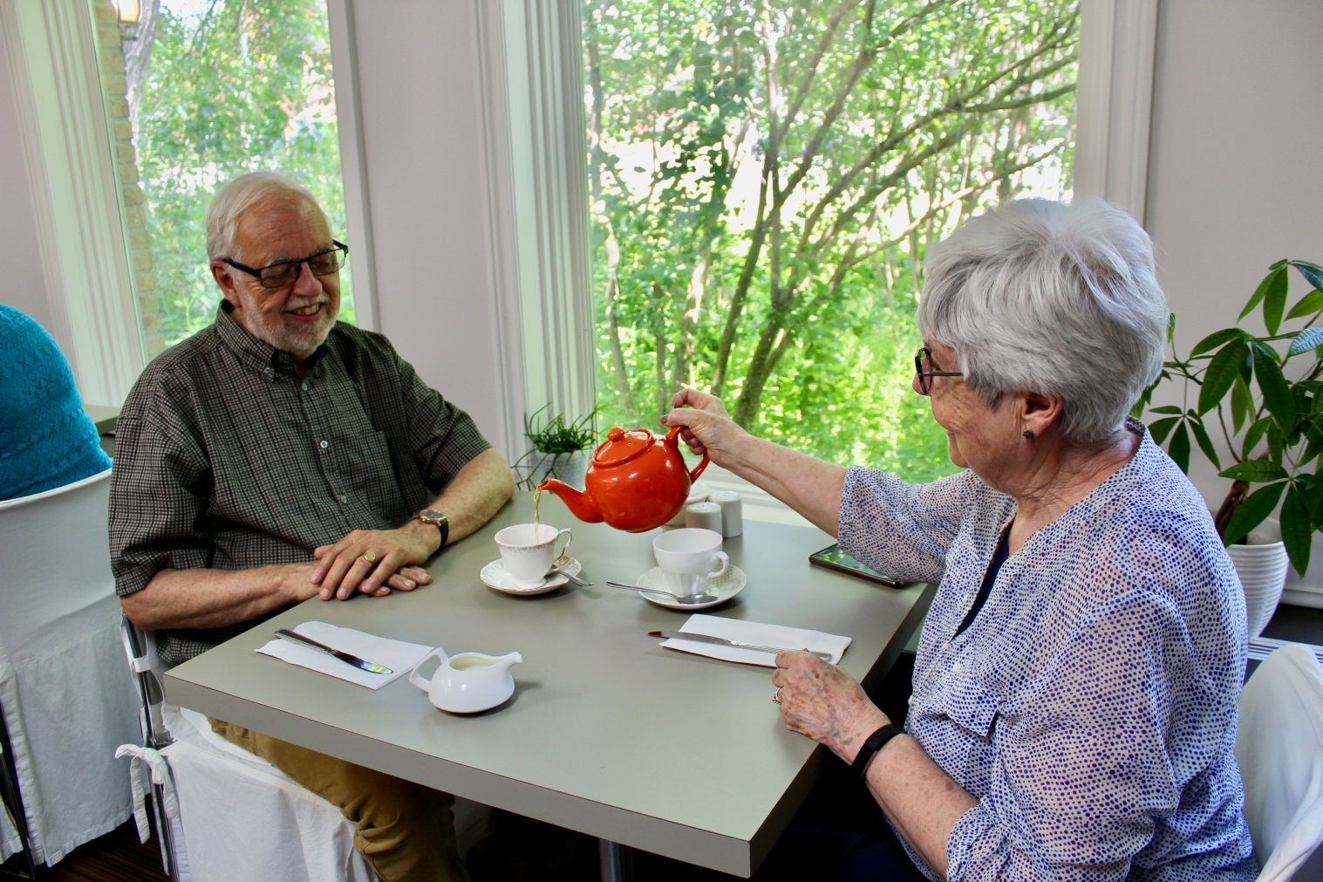

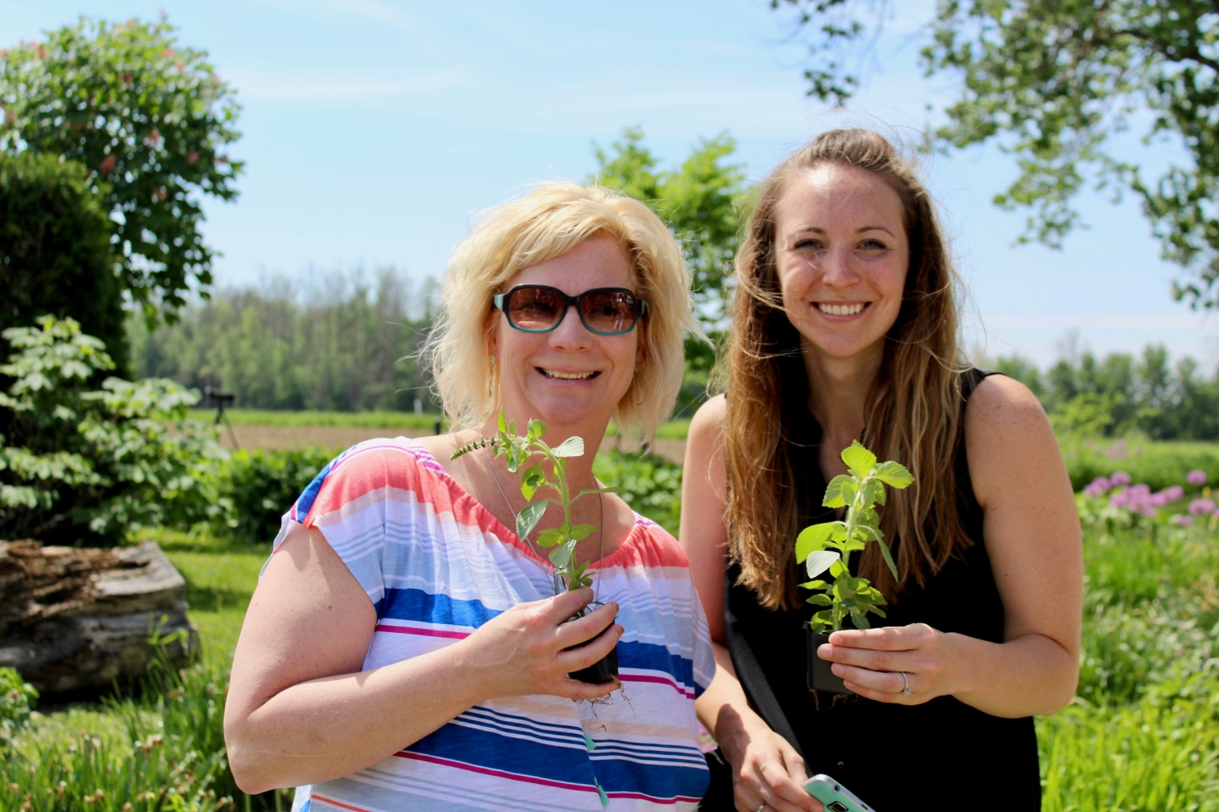
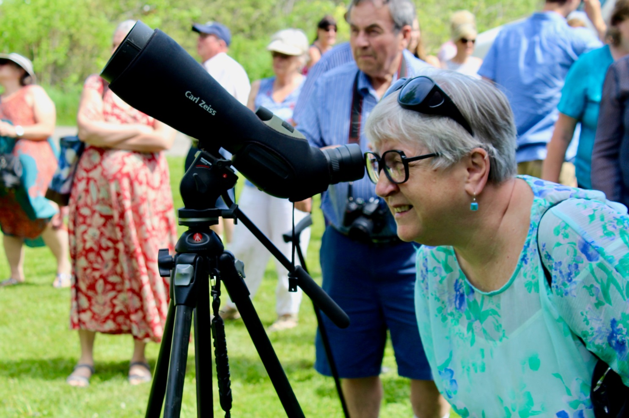

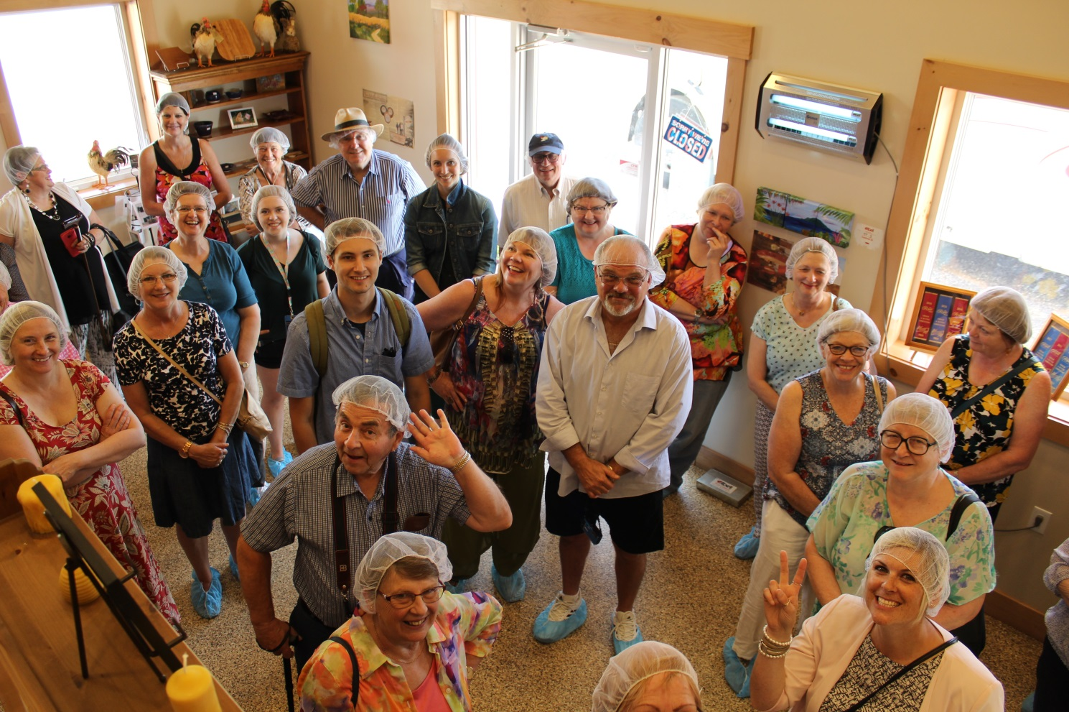

APPENDIX B

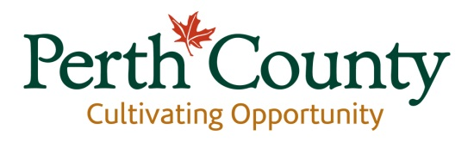
2018 Tourism Familiarization Tour – May 30th 2018
#PerthCoFam18

Hoover’s Maple Syrup
W: www.hooversmaplesyrup.com
FB: Hoover’s Maple Syrup (@HooversMaple)
IG: @hoovers.maple.syrup
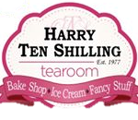
Harry Ten Shilling
FB: Harry Ten Shilling
IG: @harrytenshilling
T: @ShillingTen

Stratford Perth Museum
W: www.stratfordperthmuseum.ca
FB: The Stratford Perth Museum
IG: @stratfordperthmuseum
T: @StratPerthMuse

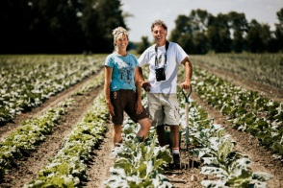
Soiled Reputation
W: www.soiledreputation.com
FB: Soiled Reputation
IG: @soiledreputation
T: @ManicOrganic

Stonetown Cheese
W: www.stonetowncheese.com
FB: Stonetown Cheese
IG: @stonetowncheese
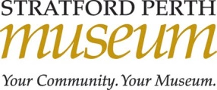
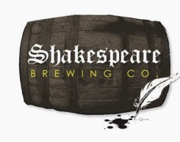
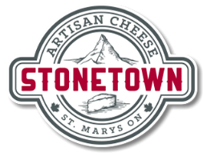
T: @stonetowncheese

Shakespeare Brewing Company
W: shakespearebrewingcompany.ca
FB: Shakespeare Brewing Company
IG: @shakespeare.brewing.company

